Job Profile

Job Title | Head of Development and Delivery
Reports to (job title) | Director of Development [&Sales]
Job Reference No. | HOMEJD325

The job in a nutshell…
You’ll lead the delivery of our regional development programme. The role requires the ability to take forward schemes from inception to completion ensuring that an excellent offer to our customers and communities lies at the heart of delivery. You will take fiscal responsibility for the performance of the projects that make up the development programme in your region and be accountable for both income and expenditure. You will be accountable for the entire development lifecycle from strategy and scheme identification through to sale or rental and for aftercare beyond.
What success will look like…
The delivery of Home Group’s strategy to build the right homes in the right places through a commercially viable mixed tenure development programme, which provides value to our customers, delivers solutions to underperforming assets and drives the company’s growth and surplus.

A regional development pipeline that meets our strategy of building the right homes in the right places, meeting required margins, improves the quality of places for our customers and delivers on the customer promise.

Development opportunities identified and secured to support the programme including successful partnerships with Homes England, and other key stakeholders.

Successful relationships with developers and contractors including joint venture arrangements that enable development opportunities aligned to our strategy.

Ensuring projects are developed collaboratively with colleagues across the organisation, supported by robust systems, procedures and delivering brilliant outcomes for our customers and the communities in which we work.

Develop, consider and evaluate solutions for complex development and delivery issues to enable Home Group to deliver its development programme.

Lead and influence to ensure the construction of development schemes in line with financial appraisals to achieve KPIs.

Manage and develop a strong, motivated team that lives Home Group’s values. All members contributing throughout the development cycle (land, build and sales etc) with a ‘one team’ approach with projects delivered effectively and efficiently, with milestones met in a timely manner.

Achievement of the best solutions possible for our customers and communities in line with Home Group's values.

An active member of Home Group’s development management team positively contributing to an ongoing sustainable business.

OFFICIAL

You’ll already have these brilliant skills, qualifications and knowledge…
- Degree level education or equivalent with demonstrable experience with large development programmes, complex multi-stakeholder projects and regeneration projects.

- Relevant professional qualification or equivalent such as CIOH. RICS or CIOB with proven work-related ability.

- Credibility in the housing sector and demonstrable industry contacts both private and public sector.

- Significant knowledge of the end-to-end development process including master planning, options analysis, Planning, design, delivery, sales and aftercare.

- Proven ability in monitoring and managing performance to deliver KPl’s at both project and programme level.

- Can demonstrate an effective contribution to operational and strategic issues at senior manager level.

- Demonstrable experience of delivering service excellence in line with Home Group values.

- Demonstrable experience of communicating with tenants and customers to support them through change and redevelopment.

- Able to build and maintain effective working relationships within and outside of the company nationally with major stakeholders.

- Strong experience in developing business plans and bids to produce an attractive commercial offer to potential partners and to meet organisational strategy underpinned by a methodical approach to risk management.

- A proven ability to manage your own P&L for your region taking responsibility for income and expenditure. Accurate monitoring and reporting is essential.

- An excellent communicator and negotiator with demonstrable skills in presenting in a range of formats and situations. Be experienced in seeking approval for proposals for investment at all levels.

- Create a regional development pipeline which meets Business Plan targets, required tenure and mix. Influence future business planning decisions.

- Comply with Development Manual procedures supporting ongoing review with the wider Development team.

We'd also love you to have, or be brilliant at... (but don't worry if not)
- Able to identify opportunities through procurement frameworks and land disposals.

- Implement the Development deal into a detailed Delivery Plan with clear milestones including legals, design, programme and financials.

- Understand, review and negotiate complex delivery structures such as Joint Ventures.

We're all accountable for...
- Health and Safety of our ourselves and others; put simply this includes taking the time to complete all learning, understanding your role-specific responsibilities, working with reasonable care and taking steps to address and report problems related to Health and Safety.

- Taking a proactive approach to your learning and development in order to be the best you can be. This includes understanding and keeping up to date with all of our relevant policies and processes as well as taking advantage of all the learning opportunities and resources available to you … they’re there for a reason but don’t worry, we’ll help keep you informed along the way.

- Promoting equality, diversity and inclusion as a top priority at Home Group; leading by example in your actions and demonstrating our Brilliant People behaviours.

- Keeping things compliant! You’ll have role-specific and organisational goals but it’s important you take these seriously and keep people and information secure and safe

- Challenging the norm – we expect all of our leaders to not just do things because 'that’s the way they have always been done’ challenge convention to drive continual improvement.

Other important stuff…
You’ll be a budget holder? No ☐ Yes ✓ … up to £ 700k plus a significant shared capital programme upto £250 million
You’ll manage people? No ☐ Yes ✓ … a team of
We all work flexibly at Home Group but the level of travel in this role is usually… Occasional X Regular ☐ Frequent
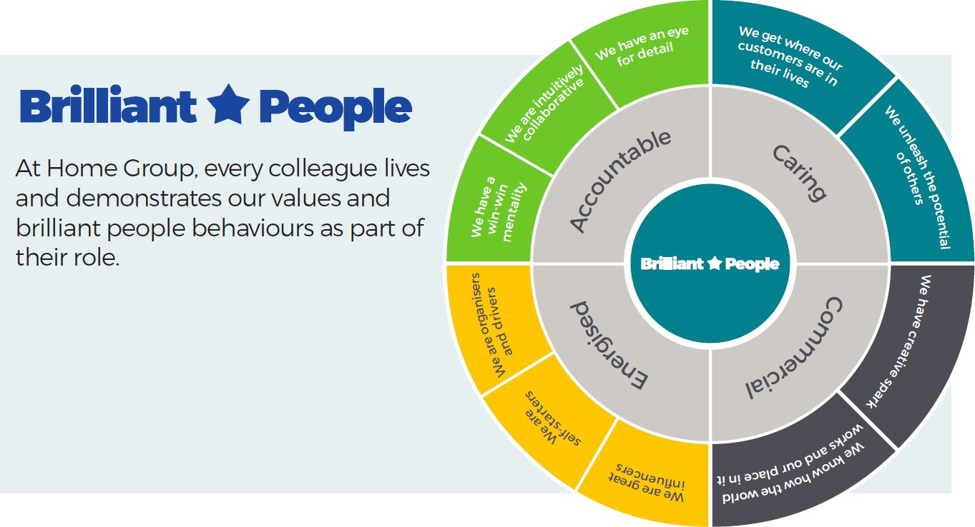

OFFICIAL

